My Notes and syntax : Python

Print fn

for i in range(10,0,-1) #prints i with decrementing

print(i,end= ‘ ’ ) #prints i with space seperation else it will automatically goes to new line

***Multiple Declarations

Like….

person1,person2,person3 = “Me”, “You”, “Him”

are possible in python

***var1= var2 = var3 = “apples”

Taking Input

n = int(input())

&& = and , || = or in python

Basic if,else

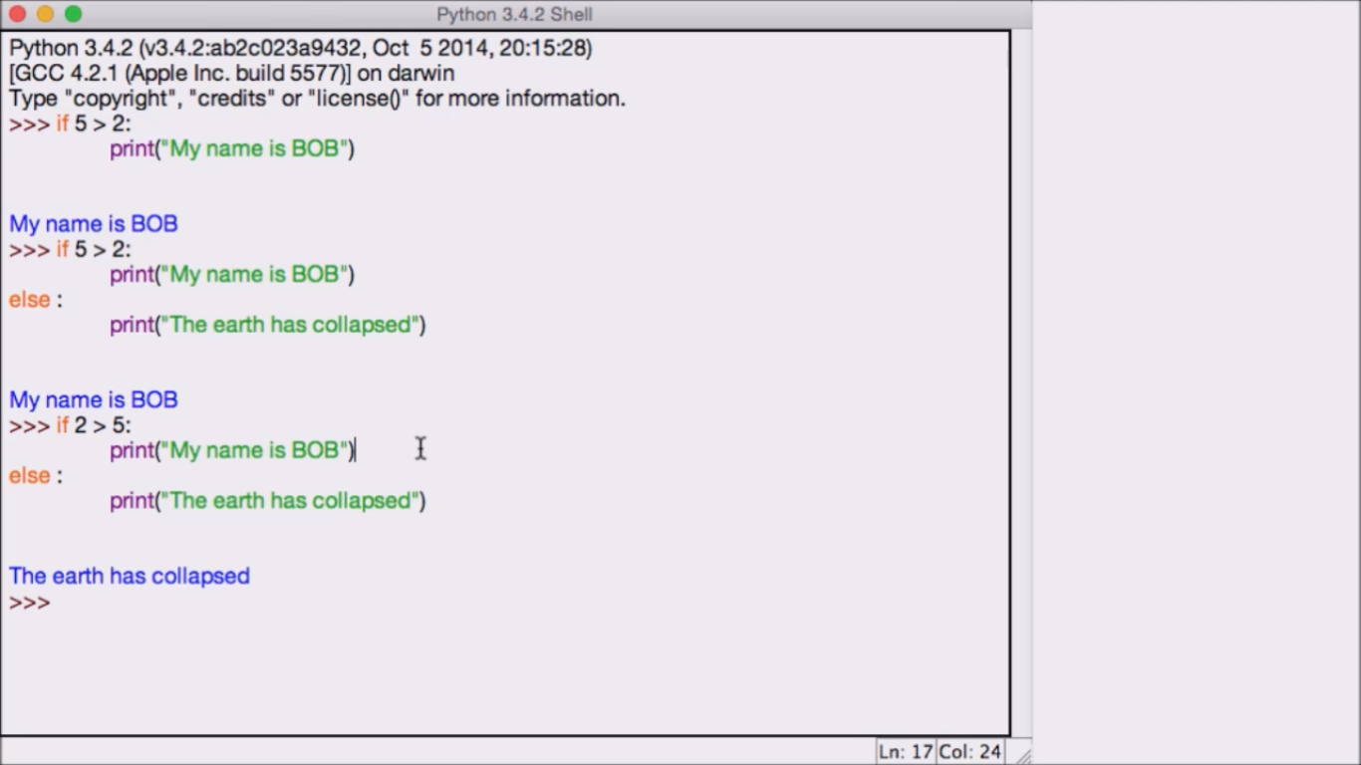

Loops with example

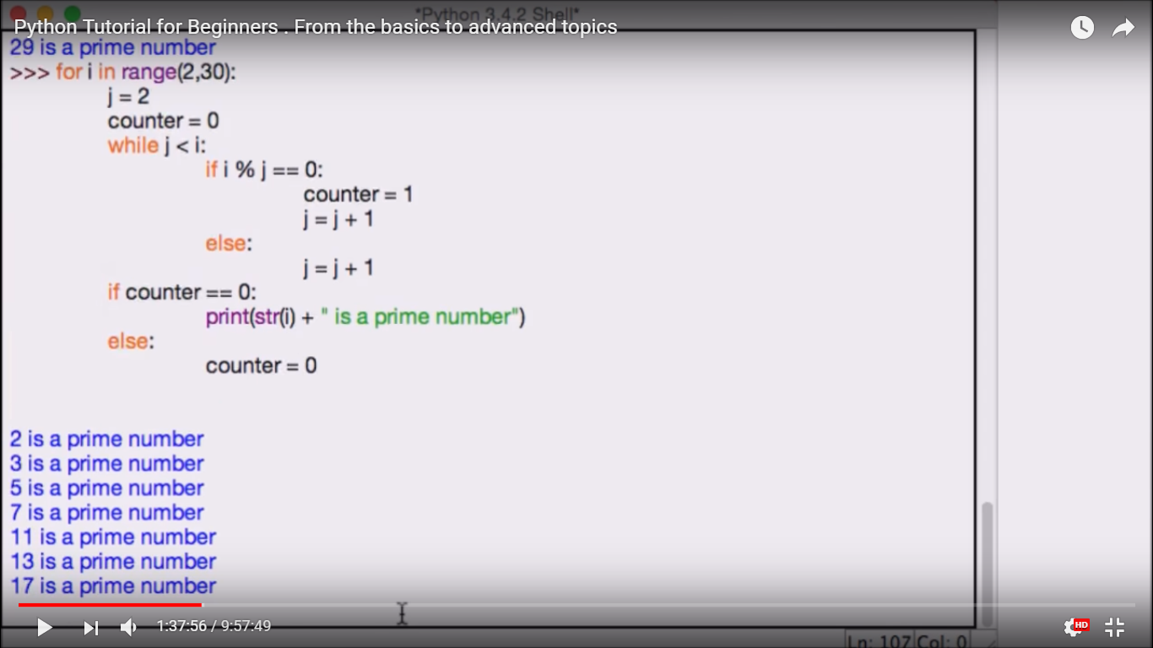

break, pass, continue (pass without bothering)

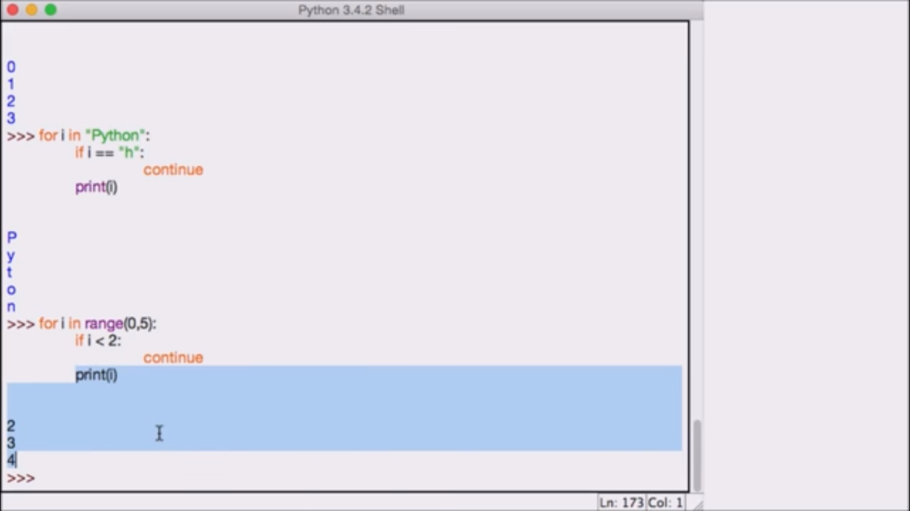

Try and except

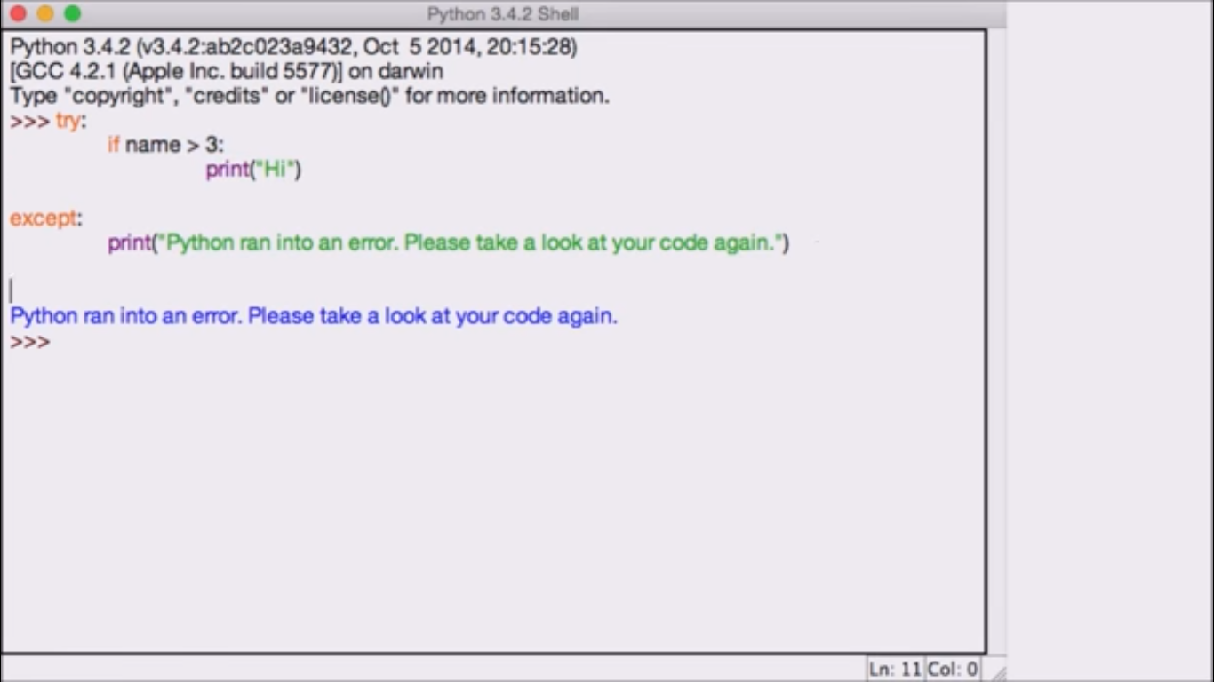

Strings

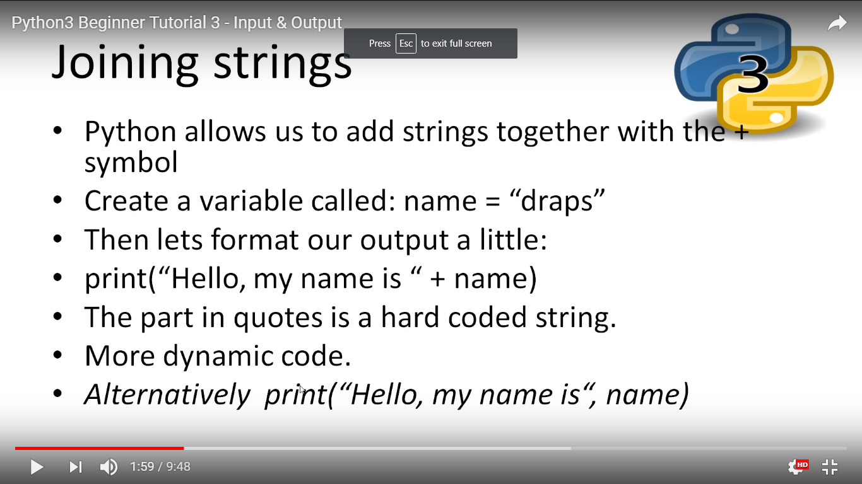

.upper() 🡪 Converts all letters to capitals

.lower() 🡪 Converts all letters to small

.capitalize() 🡪 Converts the first letter of string alone to capital.

.title() 🡪 Converts the first letter of each word to capital

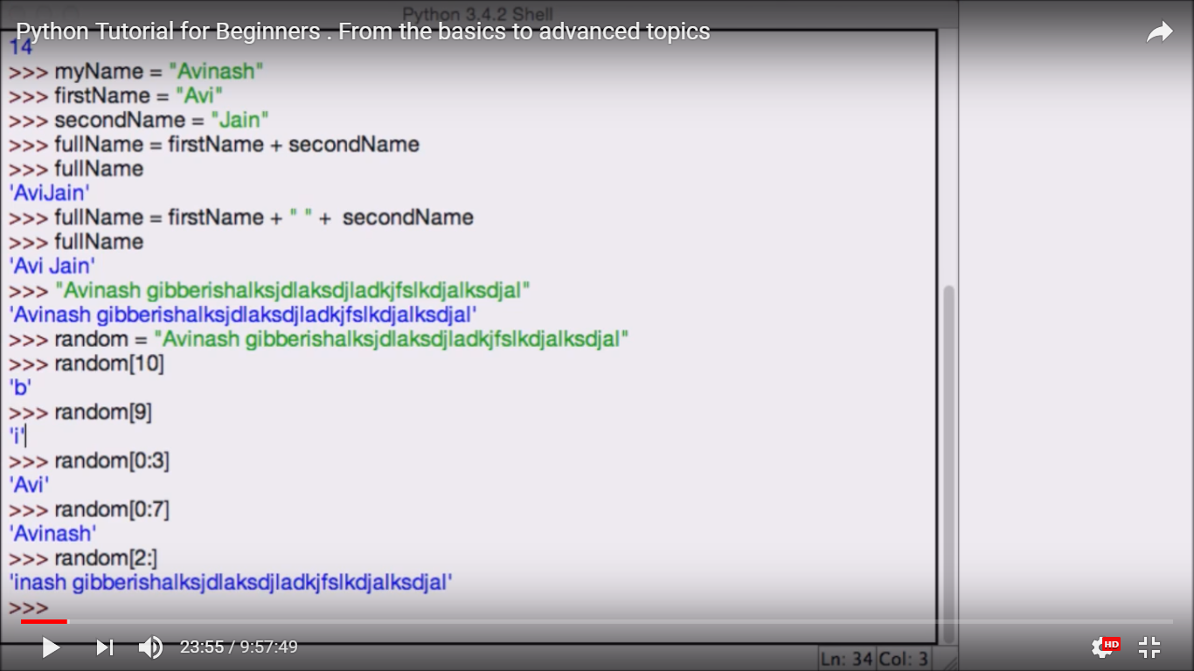

List functions

Functions in Lists

---> Another function in lists is count fn i.e.,

name_array.count(num) / name_array.count("String")

* del eg: del List[2]
* addition of 2 arrays eg : a3 = a2 + a1
* min }
* max } 🡪 f(array)
* len }
* append eg: array.append(“object”)
* Count

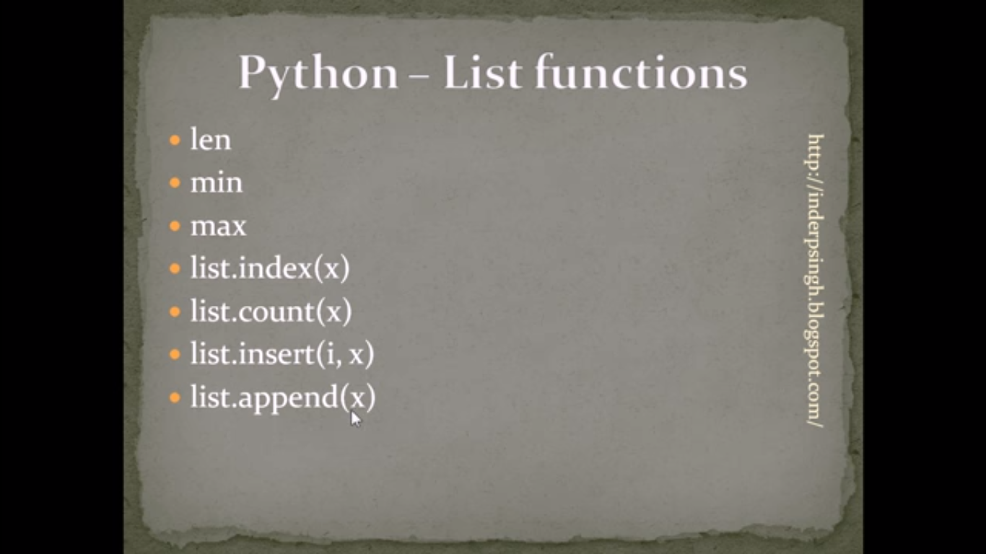

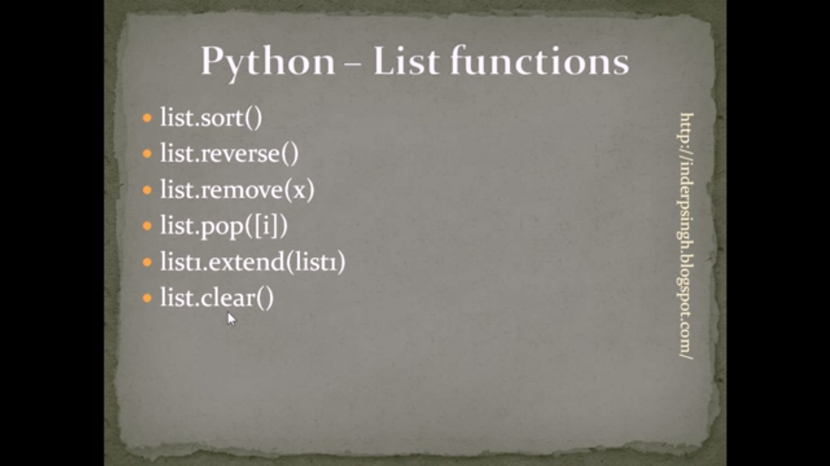

*** list.remove(x) removes the first occurance x in the array named list and throws you an error if the element x isn’t present in the array. So this function can’t be used to remove all the elements in an array

*use while loop for that and reduce the value of i , n each time you pop out an element

**

list.reverse() reverses the list

list.sort(reverse =True) sorts the list in decreasing order.

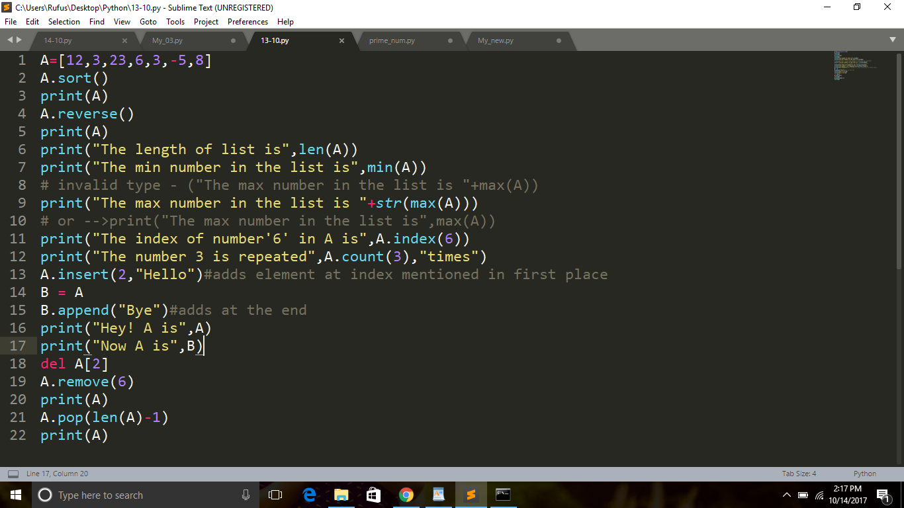

Taking inputs using split

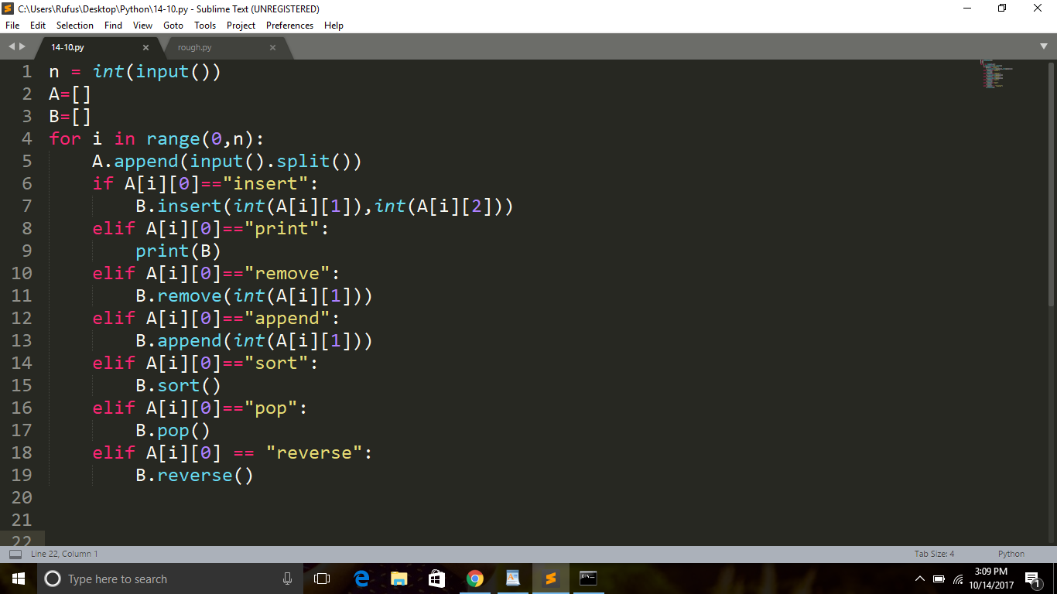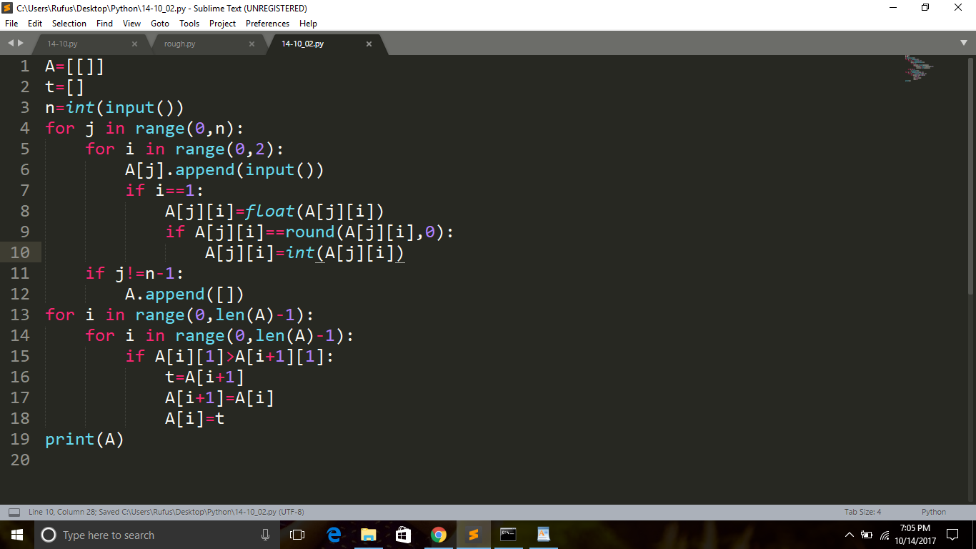

Tuples

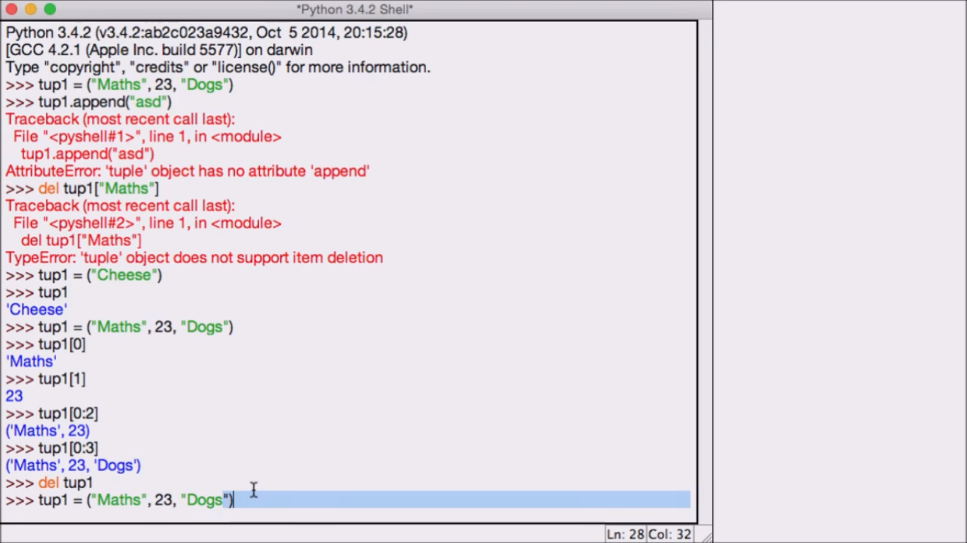

*** To convert a tuple to list or vice-versa

a = [12,43,2]

a = tuple(a)

print(a)

Output will be :

(12,43,2)

* The list is converted into a tuple and if give anything like

a.append(x)

you get an error like there is no object called append in the class tuple.

Dictionaries and their functions

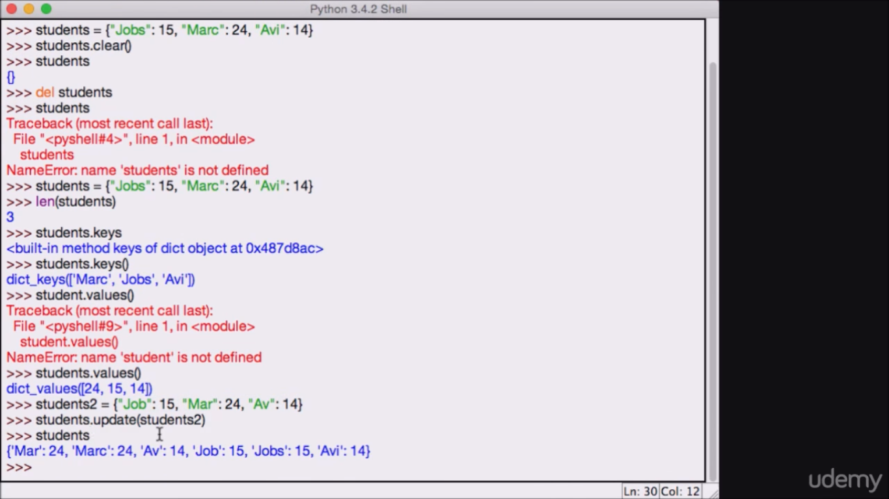

While updating if new keys were present they get added to the dictionary else they get replaced by new values i.e., they get updated

student = {“name” : “Phani”, “age”:18, “gender” : “Male” }

print(student) #prints everything

*

* del student #deletes the dict.
* Student.clear() #deletes all the keys and values from the dict.
* len(students)
* student.keys() #returns all keys
* student.values()
* student.items() # return the keys and values as pairs

Hence print(student.items()) can be used to prints that out

* del student[‘age’] #deletes age from the dict.
* var = student.pop(‘age’) # RHS returns the value of the key and pops the element out

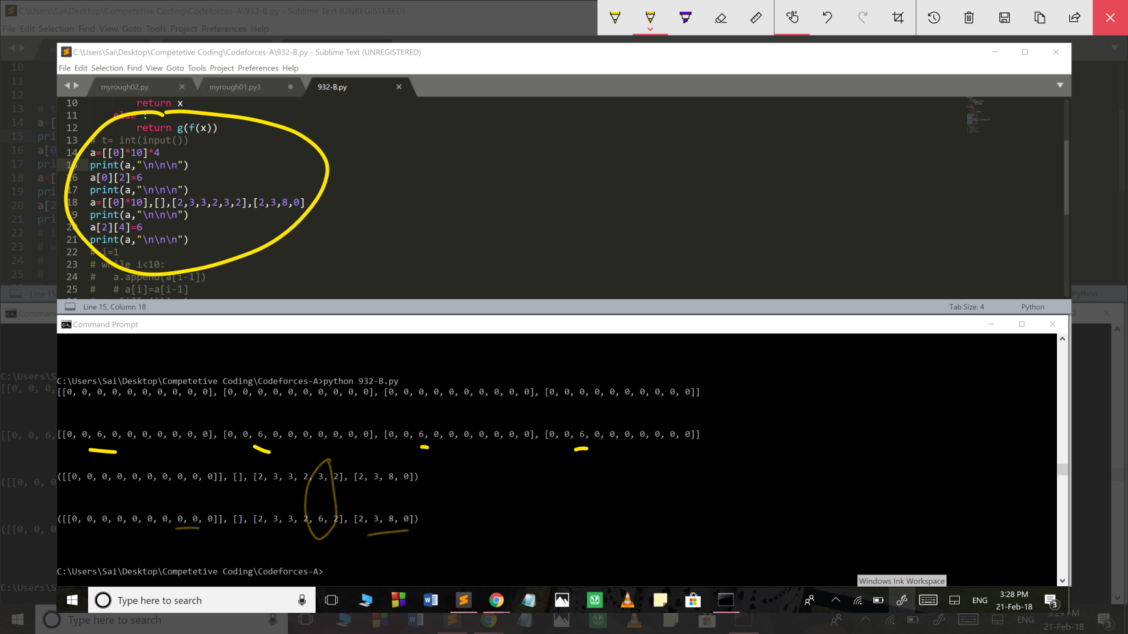

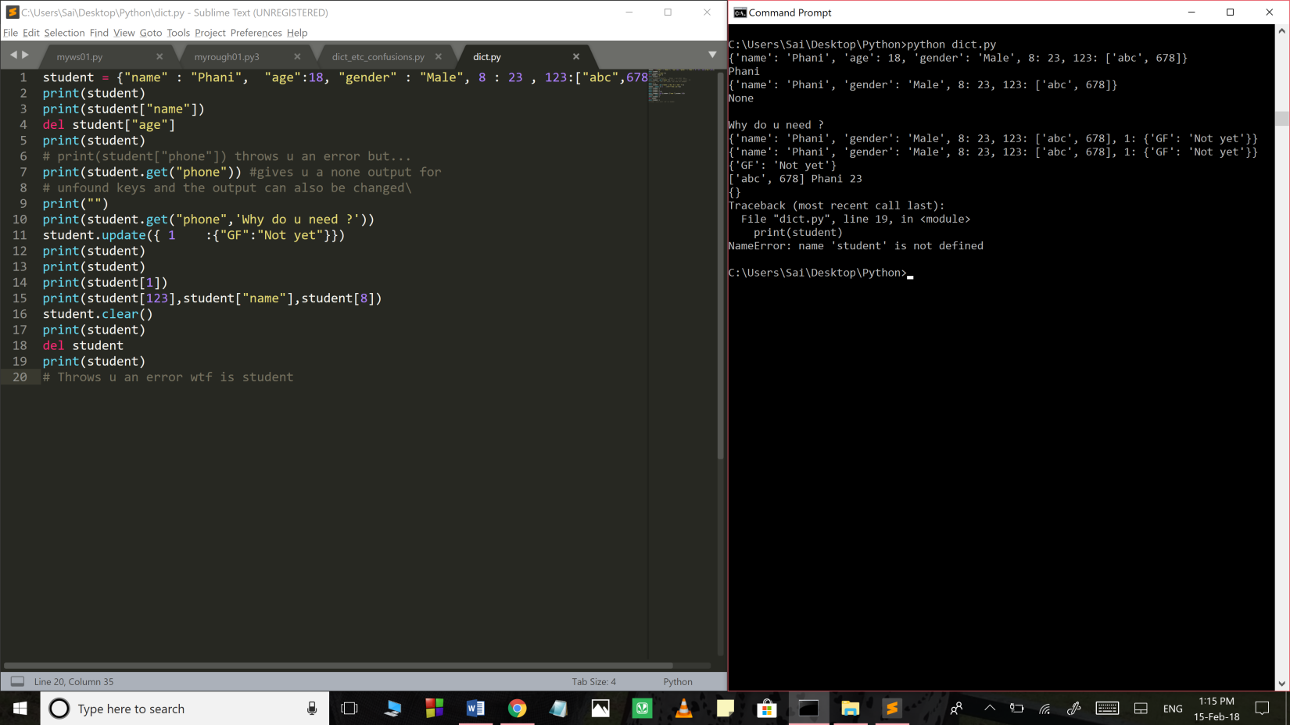

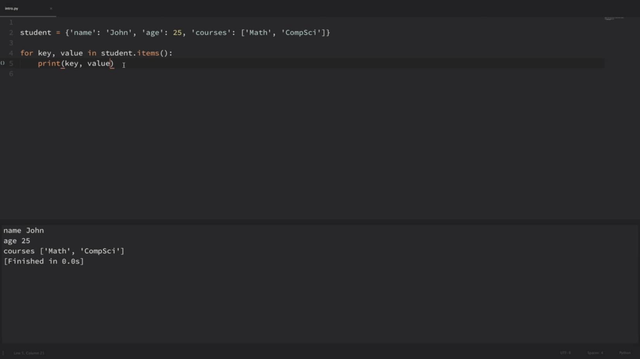

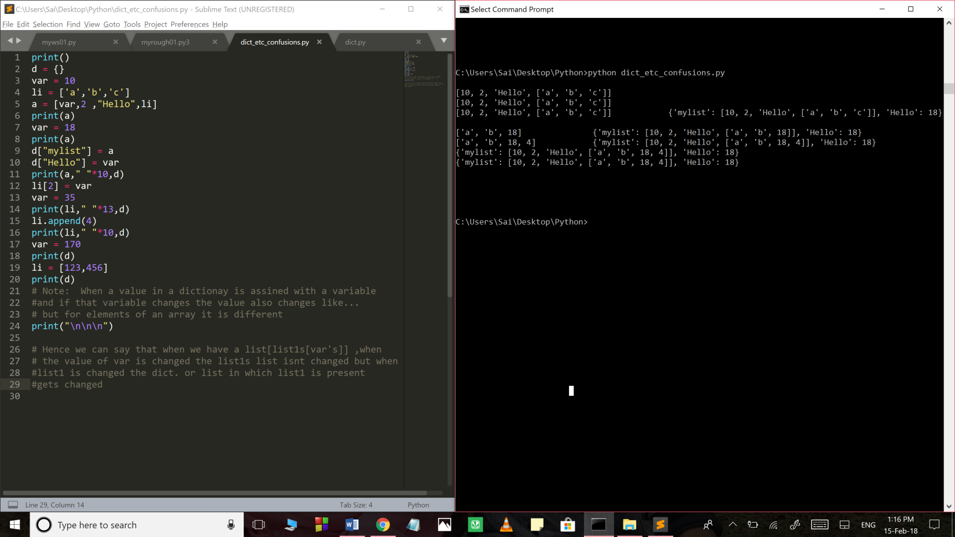

*** Note key , value aren’t keywords they are some introduced variables that refer to the 1st and 2nd elements of each pair.

List of Libraries in python

* Scipy – algorithms and mathematical tools
* Numpy – Fundamental package of Scientific computing
* BeautifulSoup – xml ,html parsing library
* Pillow - PIL (Python Imaging library)
* wxPython - GUI
* Scrapy – An open source for extracting the data we need from websites
* Requests – http request testing